**Assignment 12.1**

Importing acadgild_spark vm using Oracle vm

Install oracle virtual box from the below link:

Download the acadgild vm using the below link and save it into your system:

<https://drive.google.com/open?id=0ByJLBTmJojjzY0pvVW9YUlFwLUk>

**Steps to import acadgild vm:**

1. Open the virtual box and then follow the below steps:

Click on File ---> Import Appliance.

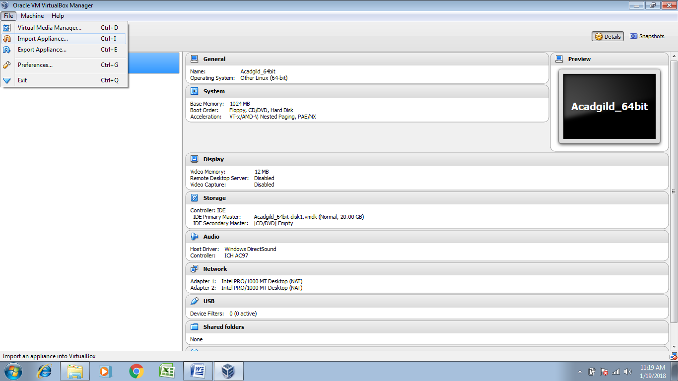

1. Click on the folder option as shown in the below screenshot to browse to the location where acadgild_spark vm is present.

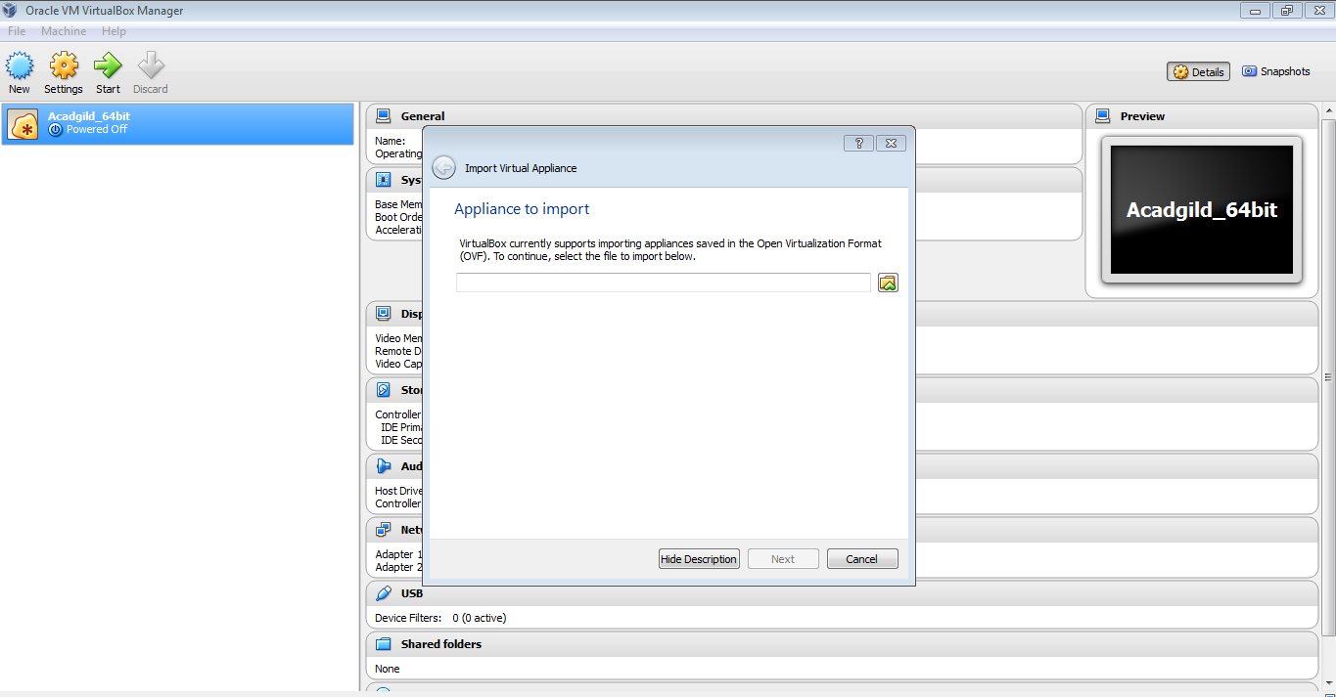

1. Select the vm to be imported and then click on open button

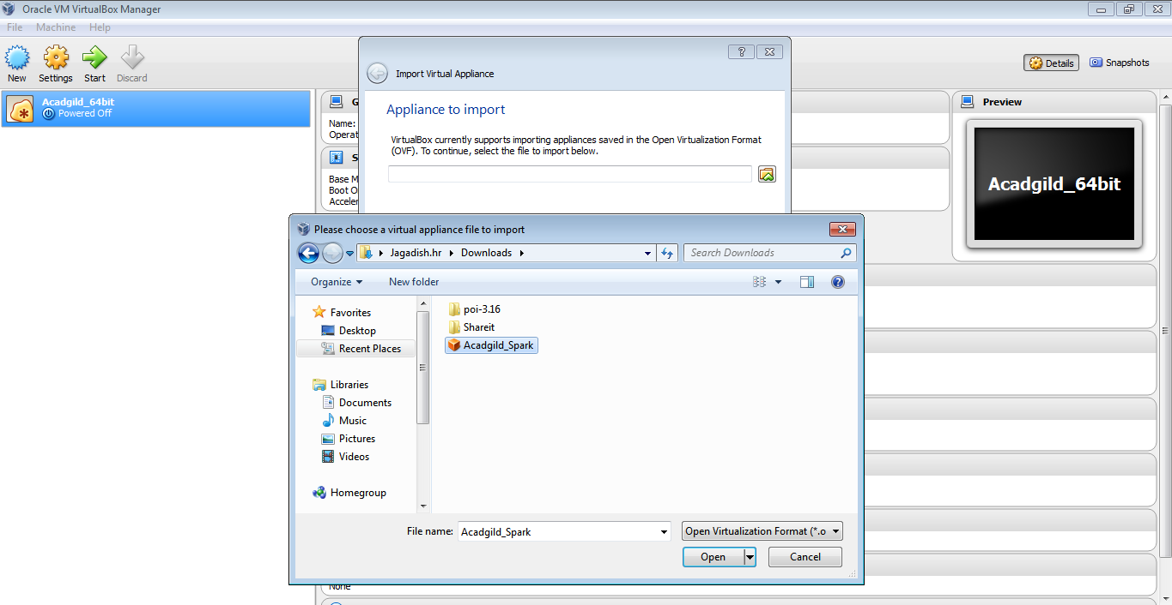

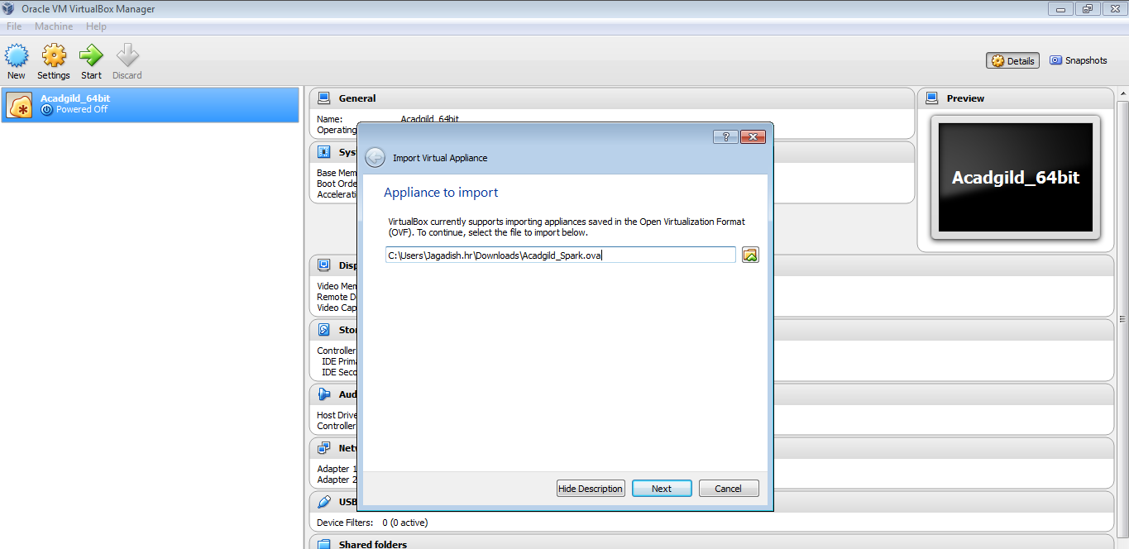

1. Click on import button to start importing the acadgild vm

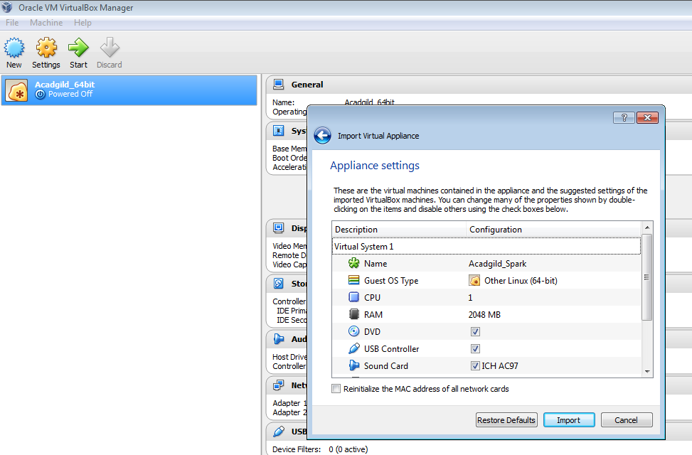

1. Once the vm starts getting imported it gives a prompt

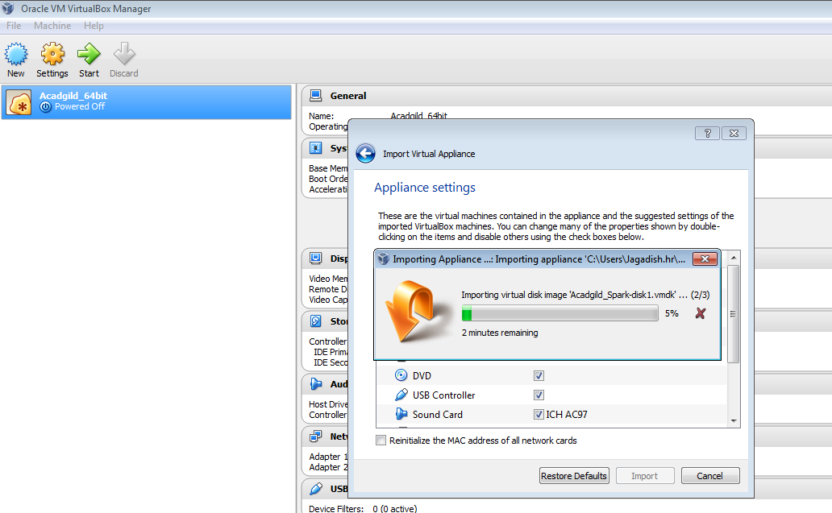

1. Once importing gets finished, we need to click on the start button:

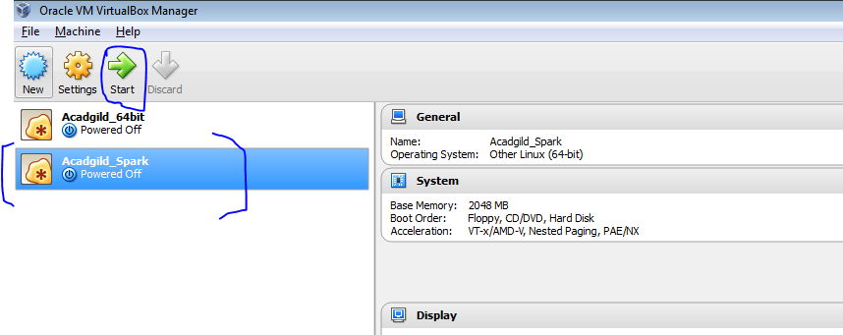

1. Acadgild_spark vm is running and started:

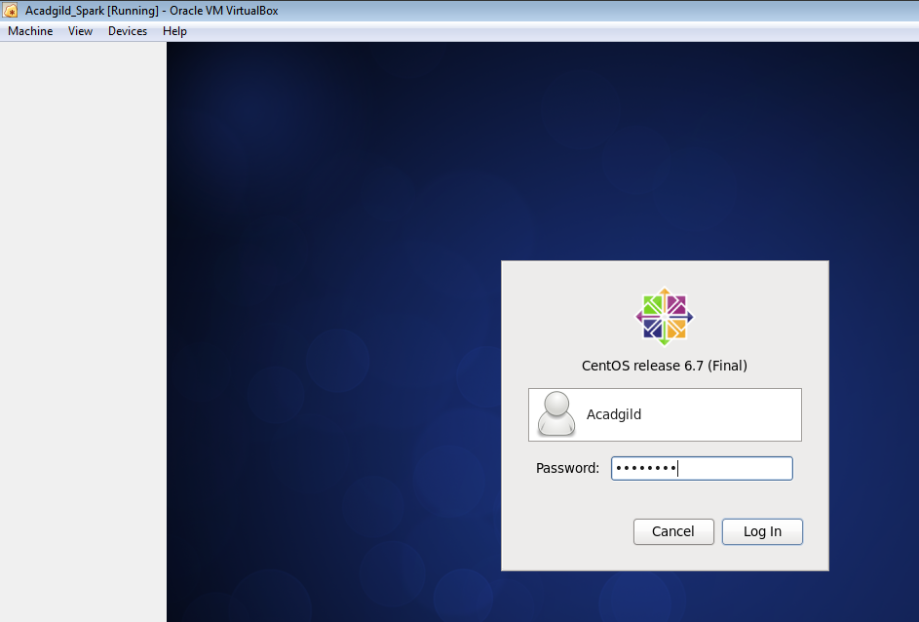

1. Open the terminal and type the command JPS to check the list of daemons, we need to start all the daemons for the first time:

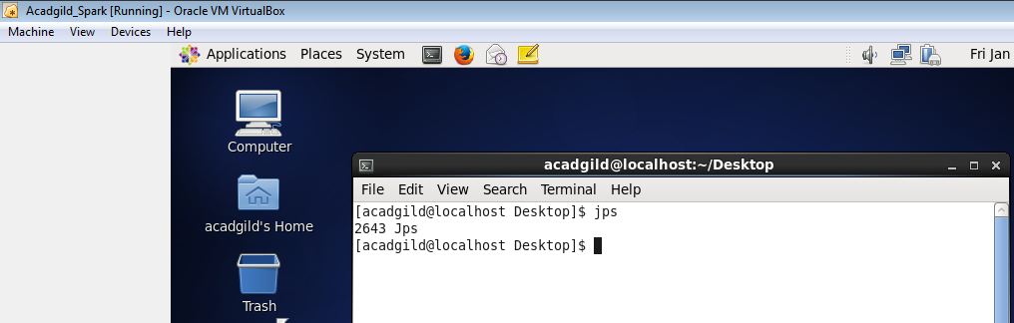

In Acadgild_spark vm ‘hadoop-2.6.0’ is present in /usr/local/ directory

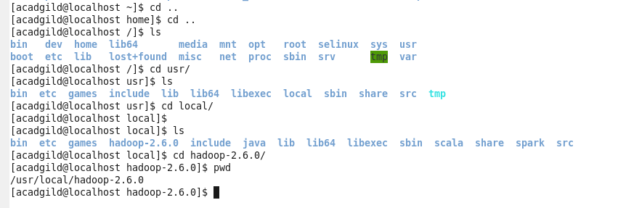

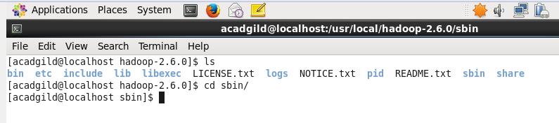

Starting namenode:



Starting datanode:



Starting resourcemanager and nodemanager:



Type command JPS to check the health of the daemons:

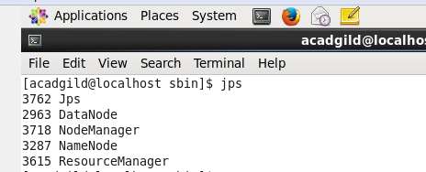

Starting spark daemons Master, Workers:

Starting Master and Slaves:

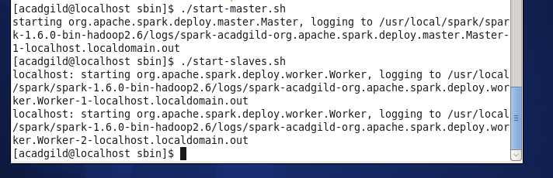

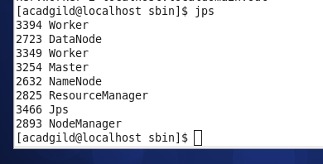

Working on Eclipse:

